**Unit – 2**

1. **Social & Cultural Change**

In 21st century society, everything is in a state of flux. Newer and newer technologies

continue to arrive, changing the way human beings live. New technologies and new

ideas allow countries to transform from poor underdeveloped nations to modern

industrialized ones. Change is inevitable and universal. To state briefly, **social change** refers to a modification in the social order of a culture. It may comprise transformation in nature, social institutions, social behaviors or social relations. Social change has been the most stable factor in the history of human civilization. Social change is a process; it is a universal law of nature that is present in every society.

Social and cultural change comes under the **forms of social change**. Social and cultural changes are often regarded as the same and denote similar kind of change. However, there are differences between the two. ‘Social’ refers to interactions and interrelationship

between people**. ‘Culture’**, on the other hand, refers to the customs, beliefs, symbols, value systems and, in general, the set of rules that are created by people in society. It can be both material and non-material. **Culture is a common way of life shared by a society or a group. According to E.B. Taylor, culture is “that complex whole which includes knowledge, belief, art, law, morals, custom and any other capabilities and habits acquired by man as a member of society. “Social learning” is by definition a necessary condition for culture.**

Material culture consists of manufacturing objects and tools like automobiles, furniture, buildings, roads, bridges, books, mobiles, TV sets and anything of that sort which is tangible and is used by the people. Non-material culture includes belief systems, values, mores, norms, habits, language, and so on.

The concept of culture relates to the body of knowledge, techniques and values through which a society directs and expresses its life as an interacting entity (Mohanty 1997, 13). So, the change in social relationships, human interactions, modifications in role expectations and role performance, and so on, are regarded as social change, whereas changes in human artifacts, beliefs, values, body of knowledge, and so on, are called as cultural change. Culture changes through time and it spreads from place to place and group to group. As Biesanz and Biesanz (1964, 61–62) put it, in the span of time since the Second world War began, immense changes have taken place. Television, since the experimental stage before the war, has entered almost every living room in the world. From the first atomic reaction in the early decades of 20th century, we have progressed to space capsules and satellites, and in a few short post-War years, plastics and synthetic fabrics, wash-and-wear clothes, stretch socks, automatic washers, dishwashers, clothes driers, food freezers and packaged mixes have changed the housewife’s fate.

It is important to mention here that sometimes changes that occur in a cultural system do not go smooth and face maladjustment with other parts of the system. Such a situation is termed as ‘cultural lag’. Defining the concept, American sociologist William Fielding Ogburn (1957) wrote, ‘A cultural lag occurs when one of the two parts of culture which are correlated changes before or in greater degree than the other parts does, thereby causing less adjustment between the two parts than existed previously.’

However, any cultural change has its impact on human relationships and, therefore, influences social changes too. The advent of mobile telephony and Internet has far reaching consequences on interpersonal relationships. Thus, cultural change positively affects social change and change in a society comes through both social and cultural changes. As Kingsley Davis stated, cultural change is broader than social change and social change is only a part of it (Shankar Rao 2000, 485). All social changes are cultural changes, but not vice-versa. Those cultural changes that affect social organizations and human interpersonal relations can be called as social changes.

* 1. **Process (Characteristics)**
* Social and cultural changes are universal phenomena.
* Social and cultural changes are regular processes.
* Social and cultural changes are not in uniformity.
* Social and cultural changes can be planed or unplanned activities.
* The pace of social and cultural change cannot be predictable.
  + 1. **Prime Processes**

1. **Innovation**
2. **Invention**
3. **Diffusion**
4. **Discovery**
5. **Innovation**

Innovation is another cardinal process of socio-cultural change. It is the mechanism of creation of new ideas, new techniques or new behaviors which make social and cultural changes possible. It is a new application of knowledge. Innovation is thus, dependent on human creativity and on the receptiveness of the community to accept or adopt the products. The ultimate source of all change is through innovation.

1. **Invention**

Invention is the creation of a new device or process. An **invention** refers to an object or concept’s initial appearance in society. It can be thought of as the creation of a product or introduction of a process for the first time. It also includes sets of behavior adopted by groups of people. They are perpetuated by being passed on to others within the group or outside it. They are also passed on to future groups and generations.

1. **Diffusion**

Diffusion is an influential process of socio-cultural evolution and change**.** Adaptation of new thing by an individual or society from another individual of a society is called diffusion of cultural attributes from the social units to the next. Therefore, diffusion refers to the spread of cultural attributes from one culture to another through regular contact between different cultural groups.

1. **Discovery**

Discovery is one of the prime process of social and cultural change. It is only when society accepts it and adopts regularly in their everyday life. Therefore, any addition in the existing socio-cultural pattern may bring a change in the society. Any invention in the field of technology, politics, philosophy, economics, culture and so on is subject to change and its socio-cultural phenomenon.

**Modernization**

modernization is the process which indicates the adoption of the modern ways of life and values. It refers to an attempt on the part of the people to adopt themselves to the present time, conditions, needs, style and ways in general. It refers to the change in people’s food habit, custom, speaking styles, language, choices, ideas and so on which in overall result the socio-cultural change of any cultural group. The modernization of cultural pattern, application of modern science and technology, innovation of knowledge etc. have brought about remarkable changes in the whole system of social relationship and stall new ideologies in the place of traditional ones.

**Acculturation**

Acculturation is also a very important component of socio-cultural change. It is the phenomena which result when group of individuals having different culture come into first-hand contact with subsequent changes in the original cultural pattern of both groups. Acculturation is the process in which two or more than two cultural groups come into continuous contact. This makes subsequences in their cultural pattern. In a simple word when the system of life in a culture begins to change under the influence of a developed culture, it is the process of acculturation.

* 1. **Theories of Social Change/Patterns of social change**
     1. **Type of Theories**

1. **Evolution**
2. **Functional**
3. **Conflict**
4. **Evolution**

* Society is viewed as moving in a definite direction.
* Auguste Comte (founder of sociology)
  + Saw human societies as moving forward in their thinking, from mythology to the scientific method
* Emile Durkheim
  + Society progressed from simple to more complex forms of social organization.

He was identified as the “father of sociology,” Auguste Comte subscribed to social evolution. He saw human societies as progressing into using scientific methods. Evolutionary theories are based on the assumption that societies gradually change from simple beginnings into even more complex forms. Early sociologists beginning with Auguste Comte believed that human societies evolve in a **unilinear** way- that is in one line of development. According to them social change meant progress toward something better.

They saw change as positive and beneficial. To them the evolutionary process implied that societies would necessarily reach new and higher levels of civilization. L. H Morgan believed that there were three basic stages in the process: **savagery**, **barbarism** and **civilization**.

Auguste Comte's ideas relating to the three stages in the development of human thought (also called intellectual phase) and also of society namely-the **theological**, the **metaphysical** and the **positive** in a way represent the three basic stages of social change.

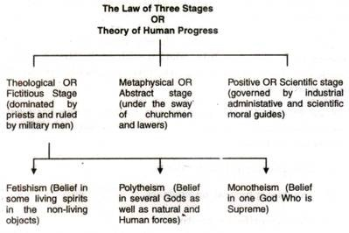

This evolutionary view of social change was highly influenced by Charles Darwin's theory of Organic Evolution. Those who were fascinated by this theory applied it to the human society and argued that societies must have evolved from the simple and primitive to that of too complex and advanced such as the western society.

Sociologists in the 19th century applied Charles Darwin's (1809– 1882)

work in biological evolution to theories of social change.

Herbert Spencer a British sociologist carried this analogy to its extremity. He argued that society itself is an organism. He even applied Darwin's principle of the survival of the fittest to human societies.

He said that society has been gradually progressing towards a better state. He argued that it has evolved from military society to the industrial society. He claimed that western races, classes or societies had survived and evolved because they were better adapted to face the conditions of life. This view known as **social Darwinism** got widespread popularity in the late 19th century. It survived even during the first phase of the 20th century.

1. **Functional**

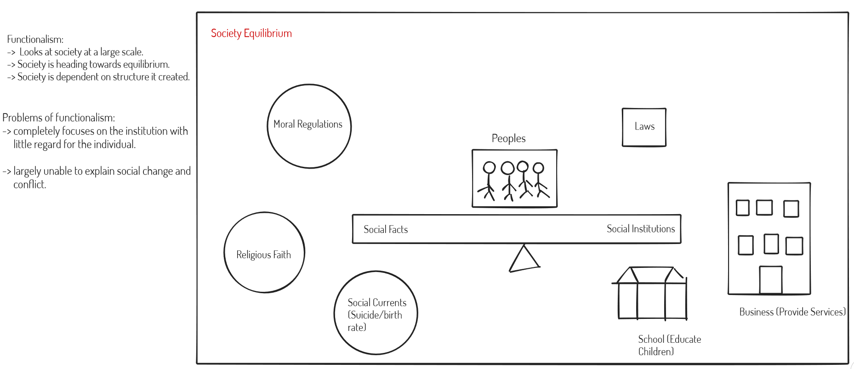In the middle decades of the 20th century a number of American sociologists shifted their attention from social dynamics to social static or from social change to social stability. Talcott Parsons stressed the importance of cultural patterns in controlling the stability of a society. According to him, society has the ability to absorb disruptive forces while maintaining overall stability. Change is not as something that disturbs the social equilibrium but as something that alters the state of equilibrium so that a qualitatively new equilibrium result.

He has stated that changes may arise from two sources. They may come from outside the society through contact with other societies. They may also come from inside the society through adjustment that must be made to resolve strains within the system. Parsons speaks of two processes that are at work in social change. In simple societies, institutions are undifferentiated that is a **single institution serves many functions**. For example, joint family are able to serve many functions like child rearing, educating the child through economic activity and recreation.

The family performs reproductive, educational, socializing, economic, recreational and other functions. A process of differentiation takes place when the society becomes more and more complex i.e., **different institution performs many functions**. Different institutions take over certain functions as specialized units to perform that particular function alone.

For example, we may observe in present societies the school has the function to educate children, media and theatres are performing recreational function, that were earlier fulfilled by the joint family system.

**Basic assumptions of functionalism**

* A society is a relatively integrated whole.
* A society tends to seek relative stability.
* Most aspects of a society contribute to the society’s well-being and survival.
* A society rests on the consensus of its members.

**Functionalist Theory**

* Parsons (1902-1979) states that functionalist theory views society as being in a natural state of equilibrium (stability). In equilibrium model, as changes occur in one part of society, adjustments must be made in other parts.
* Functionalist theory considers technology is the primary cause of social change that alters institutions and consequently threatens societal equilibrium**.**

1. **Conflict**

The conflict theory highlights social forces that produce instability and disorganization in society. Conflict is inevitable in social life. Ralf Dahrendorf who initiated conflict ideology says that “change is ubiquitous or conflict is ubiquitous”. Every element in society contributes for change.

According to Karl Marx, socio economic class conflict is the major source of tension leading to change in society. The two major social classes of capitalism the rich and the poor are polarized by their interest. Conflict is necessary for society because it forces society to adapt new conditions and change to a better form. All hitherto existing history are the history of class conflict. They are confrontation over slavery, gender discrimination and caste disparity. These conflicts are useful as they try to solve the existing problems.

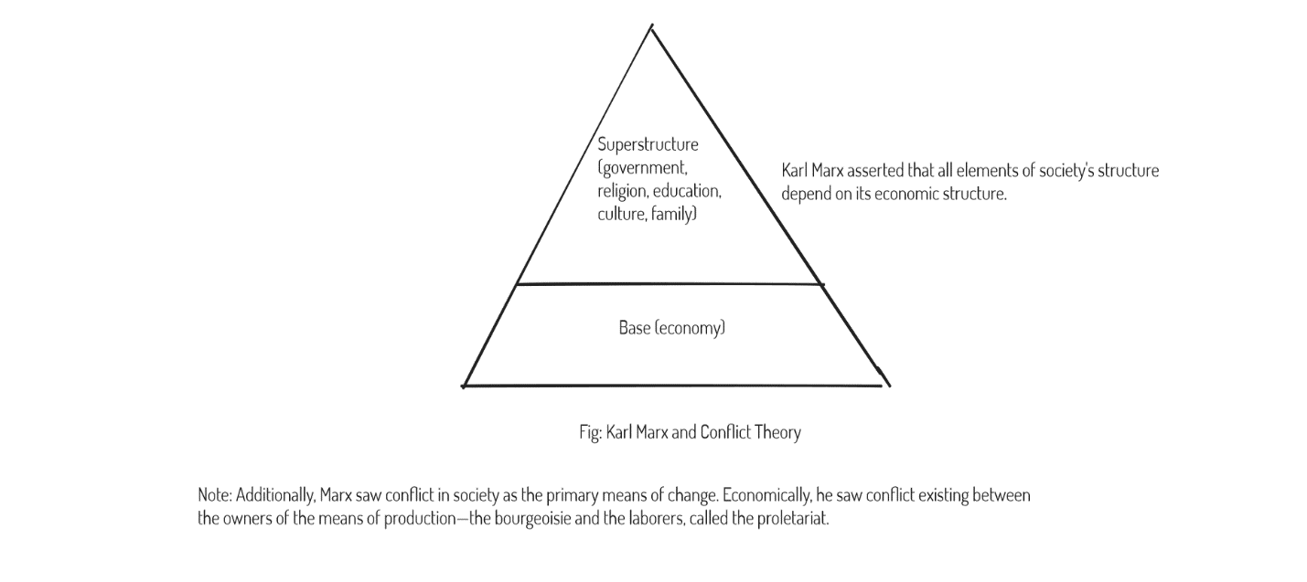

Criticism of Karl Marx conflict theory:

* Predictably, conflict theory has been criticized for its focus on change and neglect of social stability.
* Some critics acknowledge that societies are in a constant state of change, but point out that much of the change is minor or incremental, not revolutionary.
* For example, many modern capitalist states have avoided a communist revolution, and have instead instituted elaborate social service programs.
* Although conflict theorists often focus on social change, they have, in fact, also developed a theory to explain social stability.

According to George Simmel, conflicts are permanent events and also bind people of similar interests. Conflicts keep society dynamic and ever changing. The primary focus of conflict theory is exploitation, discrimination and revolt.

Conclusion of social change:

In more recent sociological writing, there is yet another perspective of social change called the ‘development perspective’. The development perspective grew from three main sources:

1. From the study of economic growth. Economists and to a great extent other

social scientists, view quantitative growth in the economic sphere of life, as an important indicator of a country’s progress. For example, they point out that a country’s prosperity can be measured in terms of GNP (Gross National

Product) or per capita income.

1. From the categorization of all societies into technologically advanced, and

less technologically advanced. Sometimes, the emphasis is on industrialization and consequently, societies that are highly industrialized, are seen to be more developed than societies which are basically agricultural.

1. From the comparison of the capitalist countries with the socialist or communist countries.
   1. **Factors of Social Change**

Social change is complex and multi-faceted phenomenon. Since, change in one sphere affects other spheres of life, it is desirable to take an integrated view of the processes of social change. To be considered are interplay of various social and non-social factors like geographical location, topography of the land, climate, soil type, plant and animal life, and other natural resources, the people’s motor skills and other abilities, technology, philosophical, religious, moral and ethical values, beliefs, social organization, and other social norms. This will facilitate a clear understanding of the role of various factors which have a collective impact on this process. We can then appreciate and understand the various change taking place and able to identify the correlation and causative effects of the various factors underlying these changes.

Social change occurs due to various factors. Some of these factors are:

1. Endogenous (i.e., internal to the society concerned) and
2. Exogenous (i.e., external to the society concerned)

Internal factors could refer to the infrastructural facilities, their distribution among people and people’s access to them. Social change occurs due to interaction and conflict caused by differential values of the old and the young, the literate and the illiterate, the urban and the rural folk.

External factors of change emphasize on the impact of such forces in a society which are beyond human control like natural disasters and unexpected development in technology.

Now we take up some factors that affect social change. The factors that will be studying in these lessons are:

1. **Economics**

Economic factors influence the quantity and direction of social change. We shall study the effects of these factors by first seeking a theoretical under printing for our analysis and by studying the available evidence. In particular we shall study the:

1. Marxian view:

Karl Marx is the chief architect of the economic theory of social change. He believes that social change is basically the result of economic factors.

The mode of production determines the social, cultural, religious and the political aspect of society.

Marx traced the development of society from agricultural to feudalism to capitalism and finally, to socialism. Capitalism emerged because of the contradictions in feudalism. Socialism would emerge from capitalism as a result of the contradictions in capitalism. There would be a class struggle between the two classes whose interest, clash because of their diverse, conflicting aim-the bourgeois (the owners of the means of production) and the proletariat (the workers who work for a wage under the bourgeois). A revolution of carried out by the workers against the capitalist would end the ills of capitalism and lead to the establishment of a socialist society.

A **socialist society** is an ideal society as there would be no classes and hence no struggle. Classlessness and the disappearance of state are the two prominent features of a socialist state. Some evidence of what Marx espouses(adoption) is seen when one studies the process and impact of industrialization.

1. Impact of industrialization:

The industrial revolution which started in Europe in late 17th century slowly found its way across the globe. The pace may have been varied in different parts of the world, but the end results were quite similar. The following changes were noticeable and had a degree of permanence attached to them:

* Production moves out of households to factories.
* Capital acquired a greater role in the production process.
* The occupational structure of the workforce changed from largely agrarian to an increasingly larger industrial workforce.
* People from all strata of society took to industrial activity.
* Women move out of homes in large numbers and entered the workforce.
* Urbanization took place at an accelerated pace.
* It triggered changes in other spheres like mass transport and communication too, thus radically altering the existing social structure.

All these changes had a dramatic impact on social relationships and brought about a lasting social change.

* Emancipation of women was a logical conclusion of this process. Within the family, the role of women changed with their economic independence.
* Similarly, production relationships changed from one amongst kinsmen to a largely impersonal relationship between the “employer” and the “employee” where skills and not loyalty became the prime creation for employment.
* Caste structure weakened, at least in urban centers and workers of different caste and religions became increasingly comfortable working with each other. Interestingly, in the absence of close family network, state and caste associations grew and the social change witnessed was the net outcome of these two opposing processes.
* Urbanization, in its wake, brought about other changes. Relationships became more impersonal as transactions acquired a commercial character. The provision of facilities like hospitals, schools, smaller houses all meant the dependence on family decreased. This was also triggered by the revolutionary changes in mass transport system, which enabled people to move to far-flung places where employment opportunities existed.
* Finally, the large influx of wage earners and self-employed to urban centers gave rise to a large and powerful middle class in society. This class not only impacted the existing social relationships but also influenced the political discourse favoring the ideas of democracy, meritocracy and egalitarianism.

1. **Technology:**

Technological progress has often triggered a long-lasting change in society.

Development and change in human societies have been linked with development and change in technology.

Sociologists say “Technology changes society by changing our environment to which we, in turn, adapt. This change is usually in the material environment and the adjustments we make to these changes often modifies customs and social institutions”.

In earlier times, technology was simple and societies were simple too. Traditional society was characterized manual labor and family was the unit of production. Production was based on human and animal power and was for domestic consumption. That was neither a governing profit motive in economic transactions nor whatever was produced was brought into market.

After the middle of the nineteenth century, the industrial revolution and industrialization took the form of a definite system. From the viewpoint of technology, the production organization developed some specific features. In this system, instead of being influenced and controlled by the environment, man tried to control it. Economy started to be based on differentiation, complex division of labor, huge production and a mechanized system of production. Large companies and corporations came into being, some of which with the passage time have acquired a multinational character.

Industrial societies are very complex and distinctly different from the earlier simple societies. In such societies, there is:

* Importance of capital instead of labor as against the norm in simple societies.
* Rise of factories as units of production instead of family.
* Use of steam, electricity and atomic power instead of energy produced by human and animal power.
* Use of machines in place of human and labor.
* Production is for exchange in the market and for profits and not just for domestic consumption.
* Development of world market instead of local market.
* Improved means of transport and communication and a currency-based economy.

Modern technology and man-made conditions have changed not only the system and quantity of production but also production relationships. Modern industrial relationships have given birth to companies, corporations, and share market, multinational companies, banks and the union of industrial workers.

1. **Education:**

Education plays an important role in social change. While, on the one hand, it is responsible for handing down traditions, culture, knowledge, and skills from one generation to another, on the other, it acts as an agent of social change. New ideas and values are initiated by it and became the goals for the young generation to pursue and achieve.

One of the sociologists has defined education as “the influence exercised by the adult generation upon those who are not yet ready for adult life”. Its objective is to awaken and develop the child those physical, intellectual and moral conditions, which are required of him, both by society as a whole and by the immediate social environment.

Society thus achieves two goals through education:

* To socialize, shape and develop the individual according to the social needs
* To fulfil society’s needs concerning human resources such as training for the specialized skills in industry and technology of the modern economy.

Formal and Informal education:

Before we explain the role of education as a factor of social change, it is important to understand the two main types of education system – formal and informal.

Education which is in a well-defined institutional setting, is formal and that which an individual acquires in the course of his daily activities and interactions in the family and in society at large is informal.

Informal education dominates in societies, which are deficient in proper schools

or where a formal schooling system is as yet underdeveloped. In tribal and agrarian societies this is apparent. In such societies, children learn the language, traditional practices, fables, folk songs, music and productive skills like cattle rearing and sowing etc., through observation and interaction with their kinsmen.

Even in advanced societies, children receive informal education along with the formal learning they undertake in schools. For example, manners, etiquette and social skills are learnt by observation of behavior of family members and those in the immediate surrounding.

Formal education characterizes modern education as we know it today. Its chief components are

* Regular and recognized schools
* Definite and properly spelt out content and
* Definite rules and regulations

We now focus on the role of education as a factor of social change. The impact of education on different aspects of social life can be examined by studying the following:

* Socialization and social control
* Development of human resources and stratification and
* Political education

1. **Demography:**

By demographic factors, we mean the factors that determine the numbers, composition, selection and the hierarchy quality of successive generations.

Broadly speaking, demography is concerned with the size and structure of human population. The social structure of a society is closely related with the changes in the size, composition and distribution of population. The size of the population is based mainly upon three factors—birth rate, death rate and migration (immigration and emigration).

The composition of population depends upon variables like age, sex, marital status, literacy etc. Changes in demographic structure, which may be caused by changes in mortality rates, will produce changes in the ratio of breadwinners to dependents.

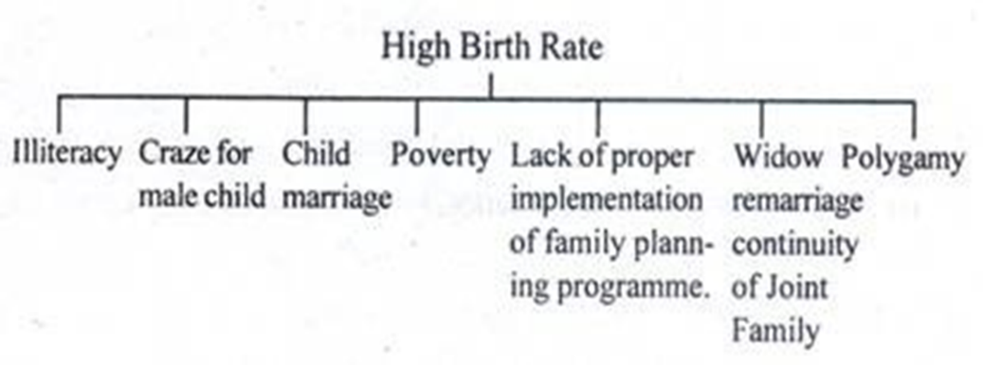

Such a change can have consequences for the structure of family, kinship, political and other institutions. The size of population affects each of us quite personally. Whether we are born into a growing or a shrinking population has a bearing on our education, the age at which we marry, our ability to get a job, the taxes we pay and many other factors.

Population analysis shows that there is a relationship between population changes and economic, social and cultural variables like poverty, illiteracy, ill-health, family structure, forms of marriage, work etc. Population growth is the most important factor in poverty.

The population of every society is always changing both in numbers as well as in composition. Population changes have occurred all through human history because of migration, war, pestilence (infectious diseases), changing mores (values, customs) etc. In modern times, adoption of two artificial ways to population growth, viz., birth control and abortion are also affecting the number and composition of population structure.

The decline of both the birth rate and the death rate brings social transformation. With changes in size go changes in composition. While the birth rate is falling, the proportion of younger people in the proportion of youth’s declines and that elders advances significant social changes occurs.

**2.4 Role of Media & Communication in Social & Cultural Change**

There are more challenging responsibilities of media in the recent era. They have a leading role in transforming people's mindset, the tough face job they ever had. Before being able to carry out this transformation job the media themselves must change their mindset. Whether people’s aspirations for vast changes get fulfilled, does not depend solely on the role of the mass media.

However, media have the potential to supply ample input and insight to political forces. The mass media have a role in educating the people on socio-cultural issues. As the media have the potential to mentally prepare people for progressive action and participation this role cannot be undermined.

Similarly, media technologies are also other factors behind socio-cultural changes. Import and export of cultures are possible through the mass media. Especially in this cyber age marked by accelerating globalization, the development of interdependent relations is inevitable. There is a give and take process in socio-cultural issues.

Mass media is a significant force in modern culture. Sociologists refer to this as a mediated culture where media reflects and creates the culture. Communities and individuals are bombarded constantly with messages from a multitude of sources including TV, billboards, and magazines and so on. These messages promote not only products, but moods, attitudes, and a sense of what is and is not important.

**Mass media** refers to media technologies used to disseminate information to a wide audience to a wide audience. The messages are communicated through television, movies, advertising, radio, the internet, magazines and newspapers.

Mass media makes possible the concept of celebrity: without the ability of movies, magazines, and news media to reach across thousands of miles, people could not become famous.

Mass media whether written, broadcast, or spoken—that reaches a large audience including television, radio, advertising, movies, the Internet, newspapers, magazines, and so forth has become a permanent part of modern culture.

In fact, only political and business leaders, as well as the few notorious outlaws, were famous in the past. Only in recent times have actors, singers, and other social elites become celebrities or “stars.”

The current level of media saturation has not always existed. As recently as the 1960s and 1970s, television, for example, consisted of primarily two networks, public broadcasting, and a few local independent stations. These channels aimed their programming primarily at two‐parent, middle‐class families. Even so, some middle‐class households did not even own a television. Today, one can find a television in the poorest of homes, and multiple TVs in most middle‐class homes. Not only has availability increased, but programming is increasingly diverse with shows aimed to please all ages, incomes, backgrounds, and attitudes.

This widespread availability and exposure make television the primary focus of most mass‐media discussions. More recently, the Internet has increased its role exponentially as more businesses and households “sign on.” Although TV and the Internet have dominated the mass media, movies and magazines—particularly those lining the aisles at grocery checkout stands—also play a powerful role in culture, as do other forms of media.

**Mass media has a prominent role to play in modern society.** It can bring about radical changes and improve social situation as it influences our social, civil, cultural, political, economic and aesthetic outlook. Modernization has converted media into an indispensable feature of human activity. However, factors like age, education, economic condition, personal needs and availability of proper components decide the quantum and frequency of media use. This is evident from the fact that most media centers are located in urban areas. The majority of consumers of media products are also concentrated in and around cities and towns.

Consciously or unconsciously the mass media has become an important part of community life. Through media we can learn many things that can be made a lesson. News about the events that occurred abroad and domestic to know quickly and easily through the mass media. This is because the mass media have the ability to deliver information effectively.

Firstly, the media can expand the horizons of thought. Most people who live in traditional societiesconsider the media have supernatural powers when you first knew him because the media can make a person see and know the places that have never visited and know people who have never met. The media has helped people recognize the developing countries of other people’s lives so that they gain a new outlook in life. The mass media can be a bridge between traditional societies transition toward a modern society.

Secondly, the mass media to focus attention. Traditional society moving toward a modern little by little began to hang up his knowledge on the mass media so that the things about what’s important, which is dangerous, what is interesting and forth from the media. As a result, over time people began to leave the customs or culture and assume that culture as something ancient and modern. Therefore, the mass media should be able to decide exactly what information or rubric that will be delivered because the media can influence in public mindset and raise people’s aspirations.

Thirdly, able to raise the aspirations of the mass media. Indirectly growing community aspirations through broadcasts or information delivered media. Many new things are delivered by media, for example of the style of dress or hairstyle that makes people compelled to make or use the same things as their views through the media. The important thing to realize and note that sometimes excessive aspirations will take the risk and bad things will not be considered as a fault.

The function of the mass media as a supporter of social changes: First, as a giver of information. In this case the function of information delivery can be done alone by the media. Without the media, it is unlikely the information can be delivered accurately and quickly.

Second, as decision-making. In this case the mass media play a role as a support which requires discussion groups that will take a decision; besides that, it expected a change in attitudes, beliefs and social norms. This means that mass media play a role in delivering information as a discussion, to convey the message of community leaders and clarify the issues that it conveys.

Third, the media serve as educators. In this case, the media can increase the level of public knowledge.

Rapid development of information and communication technologies such as mass media, causing rapid changes occur everywhere. The mass media gradually bringing in community into a new cultural pattern and begin to determine the cultural mindset and people’s behavior. Without realizing the mass media have helped set the schedule of our lives and create a number of needs. Existence of mass media in presenting the information tends to trigger a change and an impact on determining the pattern of community life. Various information presented is considered to give a tangible influence positive and negative. Slowly but effectively, the media shape public views on how a person sees his own and how one should relate to the everyday world.

The media shows the public how the standard of living worthy of a human being, thus indirectly causing the community to assess whether their environment is feasible or whether it has met these standards and this figure is heavily influenced from what’s seen, heard and read from the media. Message / information conveyed by the media can be a supportive community for the better, making people feel good about themselves, feel fairly or otherwise restore trust him or feel low than the other. The shift pattern of behavior that resulted from the mass media can occur in a family environment, school, and in social life.

The socio-psychological, information flows that continue to hit our lives will cause various effects on mental development, especially for children and adolescents. The pattern of their behavior, little by little influenced by what they receive that may deviate from the stage of mental development as well as the norms and regulations. This can happen when watching or information that should be consumed by adults was watched by children (Amini, 1993).

The impact of mass media can include a wide range of behaviors that deviate from social norms or cultural values. In modern times the public generally assumes it is not something that violates the norm, but considered part of a mass trend now. In addition, the development of mass media is very fast and can be enjoyed easily because people tend to think practically. With the development of mass media especially with the advent of electronic mass media (the modern mass media) to make people more or less constantly overwhelmed felt not satisfied and life-style instant-paced lifestyle like this without any conscious will kill the creativity that is in us in the future.

In general, the mass media is a means to deliver information from a source of information (communicator) to the recipient information (communicants). The entry of information by the mass media impact social change in society. Information thus has the power both to build and destroy. This means that the mass media in this double-faced. Information that until society can be taken differently by each individual depending on their interests and depend of society’s ability in using information coming proportionally. The most contrasting impact is felt among the community is changing lifestyles and patterns of behavior which society requires to be versatile instant, causing a shift of cultural values in public life.

Mass media presence is felt more influence on the younger generation who are in the stage of self. The information received from the media is affecting the social and cultural life of a society both in the perception of his attitude a behavior. Mass media has created a new culture that wants the public to adjust to the culture. Adjustment of public attitudes toward popular culture caused a social change in all dimensions of public life and public demands for change from traditional society to the society with a modern lifestyle.

Lifestyle changes in terms of mimesis or imitation excessively against themselves a figure that was idolized based on information obtained from the media. Usually someone will imitate everything connected with her idol was both in terms of dress, look, cut her hair or the way of speaking that reflects his idol. The above tends to be more influential on the younger generation.

* **Media and communication serve a number of functions (Positive)**
  + Increases the level of awareness
  + Helps in development efforts of the state
  + Aids in development of public opinion
  + Helps in education efforts
  + Supports democracy
  + Supports public issues
  + Creates employment opportunities (Job vacancy adv.)
* **Media and communication serve a number of functions (Negative)**
  + Consumerism
  + Moral vacuum
  + Westernization
  + Damages national image
  + False values
  + Exaggeration
  + Sensationalizing/creating certainty (scandalize or hoodwink)
  + Overload of information
  1. **Resistance of Social Change**

Not all changes or innovations are accepted by the society. The attitudes and values of a group determine what kind of changes a group is likely to accept. A process of selective acceptance operates. Some innovations are accepted instantly and some are rejected entirely.

We have accepted many material traits of Britishers such as dress pattern, china clay potteries etc., but not accepted the marriage system (courtship, premarital sex, frequent divorces etc.) because these would conflict with our values.

An innovation is most quickly accepted when its usefulness can be easily demonstrated that it is cheap and helpful. Compatible innovations are more readily accepted than those which clash with important features of the existing culture. Innovations, which are substitutive and not additive, are less readily accepted.

A society’s attitude and values greatly encourage or retard change. A people who reveres the past, worship their ancestors, honor and obey their elders, and are preoccupied with traditions and rituals will change slowly and unwillingly. A changing society has a different attitude toward change, such attitudes powerfully stimulate the proposal and acceptance of changes. Attitudes and values also affect both the amount and direction of social change.

A society’s rate and direction of changes are greatly affected by the needs its members perceive. The concept of cultural lag implies that changes in part of the culture create a need for adaptive changes in related parts of culture. “Necessity is the mother of invention”, however, it is not guarantee that needed invention or discovery will be made.

The structure of a society affects its rate of change in subtle ways. A highly conformist, authoritarian society or a highly integrated culture is less prone to change than the individualistic, permissive society or the less highly integrated culture. The structure of Nepalese society, which is traditional, rigid and tightly structured, does not permit changes easily- Such a system is strongly resistant to change.

Change is always costly. Not only does change disrupt the existing culture and destroying cherished sentiments and values, but it also involves some specific costs. Social and personal dis-organizations are costs of social change. Discoveries and inventions, as well diffused new traits and complexes, are often set off a chain reaction of change disrupting to many aspects of the culture.

* 1. **Technological Changes & its Consequences**

Science and technology are essential ingredients of modern life. They transcend local boundaries and touches lives of everyone. Evolution of mankind can be seen in terms of technological evolution as well. Invention of fire and wheel changed the face of mankind. Various historical epochs - hunter-gatherers, agrarian society and industrialist society are distinguished from each other in term of technological advancement.

The technological factors represent the conditions created by men that have a profound influence on his life. Technology is product of civilization. According to Karl Marx, even the formation of social relations and mental conceptions and attitudes are dependent upon technology.

Veblen has regarded technology as the sole explanation of social change. Ogburn says technology changes society by changing our environments to which we in turn adapt. This change is usually in the material environment and the adjustment that we make with these changes often modifies customs and social institutions.

Technology has profoundly altered our modes of life. Technology has not spared the social institutions of its effects. The institutions of family, religion, morality, marriage, state, property have been altered. Modern technology in taking away industry from the household has radically changed the family organization. Many functions of the family have been taken away by other agencies.

Marriage is losing its sanctity (purity). It is treated as a civil contract than a sacred bond. Marriages are becoming more and more unstable. Instances of divorce, desertion and separation are increasing.

Technology has elevated the status of women but it has also contributed to the stresses and strains in the relations between men and women at home. Religion is losing hold over the members. People are becoming more secular, rational and scientific but less religious in their outlook.

Inventions and discoveries in science have shaken the foundations of religion. The function of the state or the field of state activity has been widened. Modern technology has made the states to perform such functions as -the protection of the aged, the weaker section and the minorities making provision for education, health care etc.

Transportation and communication inventions are leading to a shift of functions from local government to the central government of the whole state.

The modern inventions have also strengthened nationalism. The modern governments that rule through the bureaucracy have further impersonalized the human relations.

The most striking change in modern times is the change in economic organization. Industry has been taken away from the household and new type of economic organizations have been set up such as factories, stores, banks, corporations etc.